# VISVESVARAYA TECHNOLOGICAL UNIVERSITY

## BELAGAVI – 590018, Karnataka INTERNSHIP REPORT

#### ON

“A Predictive Model for Forecasting Demand and Supply Information of Top Crops”

***Submitted in partial fulfilment for the award of degree***

## BACHELOR OF ENGINEERING

## IN

## COMPUTER SCIENCE AND ENGINEERING

***Submitted by:***

#### Achintya A A

#### 1RF19CS002



Conducted at

**COMPSOFT TECHNOLOGIES**



# RV Institute of Technology and Management

**Department of Computer Science and Engineering**

**(Affiliated to Visvesvaraya Technological University, Belagavi & Approved by AICTE, New Delhi)**

**Chaitanya Layout, JP Nagar 8th Phase, Kothanur, Bengaluru-560076**

# RV Institute of Technology and Management

**Department of Computer Science and Engineering**

**(Affiliated to Visvesvaraya Technological University, Belagavi & Approved by AICTE, New Delhi)**

**Chaitanya Layout, JP Nagar 8th Phase, Kothanur, Bengaluru-560076**

**CERTIFICATE**

This is to certify that the Internship titled **“A Predictive Model for Forecasting Demand and Supply of Top Crops”** carried out by **Mr. Achintya A A,** a bona fide student of RV Institute of Technology and Management, in partial fulfillment for the award of **Bachelor of Engineering**, in **Computer Science and Engineering** under Visvesvaraya Technological University, Belagavi, during the year 2022-2023. It is certified that all corrections/suggestions indicated have been incorporated in the report.

The project report has been approved as it satisfies the academic requirements in respect of Internship prescribed for the course Internship / Professional Practice (18CSI85)

#### Signature of Guide Signature of HOD Signature of Principal

**External Viva:**

Name of the Examiner Signature with Date

1)

2)

# D E C L A R A T I O N

I, **Achintya A A**, final year student of Computer Science and Engineering, RV Institute of Technology and Management - 560076, declare that the internship has been successfully completed, in **COMPSOFT TECHNOLOGIES**. This report is submitted in partial fulfillment of the requirements for award of Bachelor Degree in Computer Science and Engineering, during the academic year 2022-2023.

Date: 30-09-2022 :

Place: Bengaluru

USN: 1RF19CS002

NAME: Achintya A A

**OFFER LETTER**

# A C K N O W L E D G E M E N T

This Internship is a result of accumulated guidance, direction and support of several important persons. We take this opportunity to express our gratitude to all who have helped us to complete the Internship.

We express our sincere thanks to our Principal, Dr. Jayapal R, for providing us adequate facilities to undertake this Internship.

We would like to thank our Head of Department of Computer Science and Engineering, Dr. Anitha J, for providing us an opportunity to carry out Internship and for her valuable guidance and support.

We heartily extend our words of gratitude to the technical guide of Compsoft Technologies Pvt. Ltd., for his valuable advice, encouragement and suggestion given to us in the course of our internship project. We convey our gratitude to him for having constantly monitored the development of the mini- project and setting up precise deadlines.

We would like to thank all the faculty members of our department for the support extended during the course of Internship.

We would like to thank the non-teaching members of our dept, for helping us during the Internship.

Last but not the least, we would like to thank our parents and friends without whose constant help, the completion of Internship would have not been possible.

**Achintya A A**

**1RF19CS002**

# ABSTRACT

Agriculture is the biggest industry in India and it generates a significant number of employments in the country. The features of weather, geography, and soil of India are diverse. As a consequence, a range of crops are grown in the country. India crops include food grains like rice, wheat, and pulses.

The increase in population will be more in developing countries like India. When the price of any commodities set too high then the suppliers try to produce more goods to make more profit. Conversely, if the supply is less for any commodities, as consumers have to compete with one other to buy the less supplied goods, results in increased price for the commodity, making consumers suffer with the high price.

As there is no synchronization in production and demand for the agricultural commodities, either farmer fail to get good market prices for their products, or consumer suffers high prices due to less production.

Around 42% of the people depend on agriculture for their livelihood. The economic upliftment of farmers happens when there is a seamless transfer of agricultural produce from producers to the consumers. It is evident that there is a huge gap between demand and supply of various crops, due to which both farmers and consumers are facing problems. At present, in India there is no system in place to efficiently manage this demand and supply issue. The potential of present-day technologies like data analytics, machine learning can be exploited to overcome these issues. The available data about the demand, supply, price variation of the crops and other factors affecting the supply chain of agricultural produce can be used to analyze and come up with a model to predict and forecast market variations of agricultural crops.

# Table of Contents

|  |  |  |
| --- | --- | --- |
| **Sl no** | **Description** | **Page no** |
| 1 | Company Profile | 8 |
| 2 | About the Company | 10 |
| [3](https://1.bp.blogspot.com/-dODuK8N5h1Q/Wlnyb3V9HFI/AAAAAAAACL4/WxQtCJ1pM5wccDABg4wIrTBUB0vlikXQQCLcBGAs/s1600/poly1.jpg) | Introduction | 14 |
| [4](https://1.bp.blogspot.com/-dODuK8N5h1Q/Wlnyb3V9HFI/AAAAAAAACL4/WxQtCJ1pM5wccDABg4wIrTBUB0vlikXQQCLcBGAs/s1600/poly1.jpg) | System Analysis | 17 |
| [5](https://1.bp.blogspot.com/-dODuK8N5h1Q/Wlnyb3V9HFI/AAAAAAAACL4/WxQtCJ1pM5wccDABg4wIrTBUB0vlikXQQCLcBGAs/s1600/poly1.jpg) | Requirement Analysis | 19 |
| 6 | Design [Analysis](https://4.bp.blogspot.com/-IOOxgPaXMVc/Wlj3LWvcnjI/AAAAAAAACKE/UeTFYvAxDmUDel5UBjdifeWaApB3-dXVgCLcBGAs/s1600/img1.jpg) | 21 |
| 7 | [Implementation](https://4.bp.blogspot.com/-IOOxgPaXMVc/Wlj3LWvcnjI/AAAAAAAACKE/UeTFYvAxDmUDel5UBjdifeWaApB3-dXVgCLcBGAs/s1600/img1.jpg) | 24 |
| 8 | Snapshots | 26 |
| 9 | Conclusion | 32 |
| 10 | References | 34 |

[**CHAPTER**](https://1.bp.blogspot.com/-dODuK8N5h1Q/Wlnyb3V9HFI/AAAAAAAACL4/WxQtCJ1pM5wccDABg4wIrTBUB0vlikXQQCLcBGAs/s1600/poly1.jpg) **1** **COMPANY PROFILE**

# COMPANY PROFILE

## A Brief History of Compsoft Technologies

Compsoft Technologies, was incorporated with a goal ”To provide high quality and optimal Technological Solutions to business requirements of our clients”. Every business is a different and has a unique business model and so are the technological requirements. They understand this and hence the solutions provided to these requirements are different as well. They focus on clients requirements and provide them with tailor made technological solutions. They also understand that Reach of their Product to its targeted market or the automation of the existing process into e-client and simple process are the key features that our clients desire from Technological Solution they are looking for and these are the features that we focus on while designing the solutions for their clients.

Sarvamoola Software Services. is a Technology Organization providing solutions for all web design and development, MYSQL, PYTHON Programming, HTML, CSS, ASP.NET and LINQ. Meeting the ever-increasing automation requirements, Sarvamoola Software Services. specialize in ERP, Connectivity, SEO Services, Conference Management, effective web promotion and tailor-made software products, designing solutions best suiting clients requirements.

Compsoft Technologies, strive to be the front runner in creativity and innovation in software development through their well-researched expertise and establish it as an out of the box software development company in Bangalore, India. As a software development company, they translate this software development expertise into value for their customers through their professional solutions.

They understand that the best desired output can be achieved only by understanding the clients demand better. Compsoft Technologies work with their clients and help them to define their exact solution requirement. Sometimes even they wonder that they have completely redefined their solution or new application requirement during the brainstorming session, and here they position themselves as an IT solutions consulting group comprising of high caliber consultants.

They believe that Technology when used properly can help any business to scale and achieve new heights of success. It helps Improve its efficiency, profitability, reliability; to put it in one sentence “Technology helps you to Delight your Customers” and that is what we want to achieve.

# [CHAPTER](https://1.bp.blogspot.com/-dODuK8N5h1Q/Wlnyb3V9HFI/AAAAAAAACL4/WxQtCJ1pM5wccDABg4wIrTBUB0vlikXQQCLcBGAs/s1600/poly1.jpg) 2 ABOUT THE COMPANY

1. **ABOUT THE COMPANY**



Compsoft Technologies is a Technology Organization providing solutions for all web design and development, MYSQL, PYTHON Programming, HTML, CSS, ASP.NET and LINQ. Meeting the ever-increasing automation requirements, Compsoft Technologies specialize in ERP, Connectivity, SEO Services, Conference Management, effective web promotion and tailor-made software products, designing solutions best suiting clients requirements. The organization where they have a right mix of professionals as a stakeholder to help us serve our clients with best of our capability and with at par industry standards. They have young, enthusiastic, passionate and creative Professionals to develop technological innovations in the field of Mobile technologies, Web applications as well as Business and Enterprise solution. Motto of our organization is to “Collaborate with our clients to provide them with best Technological solution hence creating Good Present and Better Future for our client which will bring a cascading a positive effect in their business shape as well”. Providing a Complete suite of technical solutions is not just our tag line, it is Our Vision for Our Clients and for Us, we strive hard to achieve it.

## Products of Compsoft Technologies.

**Android Apps**

It is the process by which new applications are created for devices running the Android operating system. Applications are usually developed in Java (and/or Kotlin; or other such option) programming language using the Android software development kit (SDK), but other development environments are also available, some such as Kotlin support the exact same Android APIs (and bytecode), while others such as Go have restricted API access.

The Android software development kit includes a comprehensive set of development tools. These include a debugger, libraries, a handset emulator based on QEMU, documentation, sample code, and tutorials. Currently supported development platforms include computers running Linux (any modern desktop Linux distribution), Mac OS X 10.5.8 or later, and Windows 7 or later. As of March 2015, the SDK is not available on Android itself, but software development is possible by using specialized Android applications.

**Web Application**

It is a client–server computer program in which the client (including the user interface and client- side logic) runs in a web browser. Common web applications include web mail, online

retail sales, online auctions, wikis, instant messaging services and many other functions. web applications use web documents written in a standard format such as HTML and JavaScript, which are supported by a variety of web browsers. Web applications can be considered as a specific variant of client–server software where the client software is downloaded to the client machine when visiting the relevant web page, using standard procedures such as HTTP. The Client web software updates may happen each time the web page is visited. During the session, the web browser interprets and displays the pages, and acts as the universal client for any web application. The use of web application frameworks can often reduce the number of errors in a program, both by making the code simpler, and by allowing one team to concentrate on the framework while another focuses on a specified use case. In applications which are exposed to constant hacking attempts on the Internet, security- related problems can be caused by errors in the program.

Frameworks can also promote the use of best practices such as GET after POST. There are some who view a web application as a two-tier architecture. This can be a “smart” client that performs all the work and queries a “dumb” server, or a “dumb” client that relies on a “smart” server. The client would handle the presentation tier, the server would have the database (storage tier), and the business logic (application tier) would be on one of them or on both. While this increases the scalability of the applications and separates the display and the database, it still doesn’t allow for true specialization of layers, so most applications will outgrow this model. An emerging strategy for application software companies is to provide web access to software previously distributed as local applications. Depending on the type of application, it may require the development of an entirely different browser-based interface, or merely adapting an existing application to use different presentation technology. These programs allow the user to pay a monthly or yearly fee for use of a software application without having to install it on a local hard drive. A company which follows this strategy is known as an application service provider (ASP), and ASPs are currently receiving much attention in the software industry.

Security breaches on these kinds of applications are a major concern because it can involve both enterprise information and private customer data. Protecting these assets is an important part of any web application and there are some key operational areas that must be included in the development process. This includes processes for authentication, authorization, asset handling, input, and logging and auditing. Building security into the applications from the beginning can be more effective and less disruptive in the long run.

**Web design**

It is encompassing many different skills and disciplines in the production and maintenance of websites. The different areas of web design include web graphic design; interface design; authoring, including standardized code and proprietary software; user experience design; and

search engine optimization. The term web design is normally used to describe the design process relating to the front-end (client side) design of a website including writing mark up. Web design partially overlaps web engineering in the broader scope of web development. Web designers are expected to have an awareness of usability and if their role involves creating mark-up then they are also expected to be up to date with web accessibility guidelines. Web design partially overlaps web engineering in the broader scope of web development.

## Departments and services offered

Compsoft Technologies plays an essential role as an institute, the level of education, development of student’s skills is based on their trainers. If you do not have a good mentor then you may lag in many things from others and that is why we at Compsoft Technologies gives you the facility of skilled employees so that you do not feel unsecured about the academics. Personality development and academic status are some of those things which lie on mentor’s hands. If you are trained well then you can do well in your future and knowing its importance of Compsoft Technologies always tries to give you the best.

They have a great team of skilled mentors who are always ready to direct their trainees in the best possible way they can and to ensure the skills of mentors we held many skills development programs as well so that each and every mentor can develop their own skills with the demands of the companies so that they can prepare a complete packaged trainee.

## Services provided by Compsoft Technologies.

* Core Java and Advanced Java
* Web services and development
* Dot Net Framework
* Python
* Selenium Testing
* Conference / Event Management Service
* Academic Project Guidance
* On The Job Training
* Software Training

# [CHAPTER](https://1.bp.blogspot.com/-dODuK8N5h1Q/Wlnyb3V9HFI/AAAAAAAACL4/WxQtCJ1pM5wccDABg4wIrTBUB0vlikXQQCLcBGAs/s1600/poly1.jpg) 3 INTRODUCTION

1. **INTRODUCTION**

## Introduction to ML

Machine Learning is undeniably one of the most influential and powerful technologies in today’s world. More importantly, we are far from seeing its full potential. There’s no doubt, it will continue to be making headlines for the foreseeable future. This article is designed as an introduction to the Machine Learning concepts, covering all the fundamental ideas without being too high level.

Machine learning is a tool for turning information into knowledge. In the past 50 years, there has been an explosion of data. This mass of data is useless unless we analyze it and find the patterns hidden within. Machine learning techniques are used to automatically find the valuable underlying patterns within complex data that we would otherwise struggle to discover. The hidden patterns and knowledge about a problem can be used to predict future events and perform all kinds of complex decision making.

There are multiple forms of Machine Learning; supervised, unsupervised, semi-supervised and reinforcement learning. Each form of Machine Learning has differing approaches, but they all follow the same underlying process and theory. This explanation covers the general Machine Leaning concept and then focusses in on each approach.

To maximize the chance of generalizability to the performance of the algorithm on unseen data, the training dataset is usually split into a slightly smaller training dataset and a separate validation dataset. Metrics used for evaluation of a model depend upon the model itself and whether it is in the training or testing phase. The validation dataset is meant to mimic the test dataset and helps data scientists tune an algorithm by identifying when a model may generalize well and work in a new population.

## Problem Statement

The world's population may reach 6.3 billion and this population growth may surge to 9.5 to 10.0 billion by 2050. The increase in population will be more in developing countries like India than developed countries. The economic growth also has been increased dramatically in the recent years in such countries. The increase in income results in increased demand for more and better food. In India, for instance, the increased income has doubled the expenditure on food commodities. The same pattern has been observed in all the developing countries. It has been calculated that, due to increase in population and individual’s income, the world food demand will double by 2050. In topical years, there has been a significant variation in the rates of agricultural products like fruits, flowers, food- grains and vegetables, etc.

As shown in Fig 1, the price variation is mainly due to the mismatch in demand and supply of these agricultural products. When the price of any commodity is set too high then the suppliers (farmers) try to produce more goods to make more profit. When the price of any commodity is set too high then the consumers will tend to purchase less because of high rate, and the suppliers (farmers) incurs the loss.

Conversely, if the supply is less for any commodities, as consumers have to compete with one other to buy the less supplied goods, results in increased price.Hence, in order to reduce the mismatch in demand and supply of food crops effectively, primarily the expected demand for various food commodities needs to be forecasted and guide the farmers accordingly.

1

**Fig. 1**

**.**

**Demand, supply and price inflation**

**n**

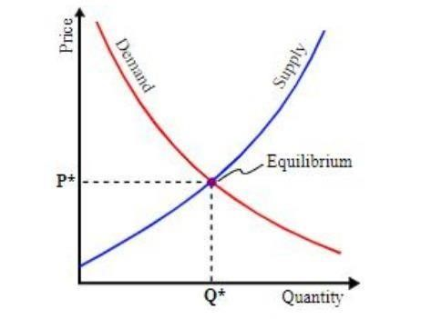

So, there is a need for some system that could guide the farmers in selecting and growing the crops to satisfy the actual demand of the society. This could eliminate the gap between the consumer’s demand and producer’s supply and reducing the loss for both consumers and farmers. Big data analytics as an emerging trend could help in providing solutions for such problems. An effective forecasting model is proposed and has been implemented in this paper that (i) determine the gap between the demand for and supply of the crops that have to be reduced. (ii) Forecasts the demand of various food commodities that helps the system to guide the farmers in selecting and growing the appropriate crops to satisfy the demand and hence reducing the gap or mismatch between the demand and supply of the crops.

# [CHAPTER](https://1.bp.blogspot.com/-dODuK8N5h1Q/Wlnyb3V9HFI/AAAAAAAACL4/WxQtCJ1pM5wccDABg4wIrTBUB0vlikXQQCLcBGAs/s1600/poly1.jpg) 4 SYSTEM ANALYSIS

**4. SYSTEM ANALYSIS**

## Existing System

The necessary data required for this analysis has been gathered from the sources like Ministry of-Agriculture, Agmarknet, Directorate of marketing and Inspection, Ministry-of-Agriculture and Farmers-Welfare, Government of India, National Horticulture Board (NHB) India, HOPCOMS Horticultural Producer’s Cooperative Marketing and Processing Society Limited by applying Web scraping methods and stored in the local repository and detailed market survey.

Data preprocessing module removes the noise from the collected data sets and builds the missing values before applying forecasting algorithm for better performance. All the data sets collected were integrated into a single dataset. During this process, incomplete information is eliminated and all NA (Not Applicable) values are aggregated to the average value.

The data sets collected contains multiple attributes, the required attributes are separated and stored as a separate data frame, and then the data frame is converted to time series data. The pre-processed data has been stored and processed as clusters in distributed mode for effective application of the algorithm and analysis. The Hadoop HDFS and Map Reduce paradigm have been used to provide a distributed data storing and parallel processing.

## Proposed System

The proposed DPFM model is implemented using the integrated R-Hadoop machine learning based prediction modeling that provides scalable and parallel processing environment. Also, a Map-Reduce programming model has been developed in R environment to perform the efficient analysis of the data stored in Hadoop clusters. The server that runs R submits the jobs to Hadoop which in turn distributes the work among m machines in the cluster and gets the result.

# [CHAPTER](https://1.bp.blogspot.com/-dODuK8N5h1Q/Wlnyb3V9HFI/AAAAAAAACL4/WxQtCJ1pM5wccDABg4wIrTBUB0vlikXQQCLcBGAs/s1600/poly1.jpg) 5 REQUIREMENT ANALYSIS

**5. REQUIREMENT ANALYSIS**

## Hardware Requirement Specification

The software requirement specification can produce at the culmination of the analysis task. The function and performance allocated to software as part of system engineering are refined by established a complete information description, a detailed functional description, a representation of system behavior, and indication of performance and design constrain, appropriate validate criteria, and other information pertinent to requirements.

* System: i3 2.4 GHz & above
* Hard Disk: 256GB
* RAM: 4GB

## Software Requirement Specification

* Operating system: Windows 10
* Coding Language: Python
* Application: Jupyter Notebook.

There are a lot of python libraries which could be used to build visualization like matplotlib, vispy, bokeh, seaborn, pygal, folium, plotly, cufflinks, and networkx. Of the many, matplotlib and seaborn seems to be very widely used for basic to intermediate level of visualizations.

However, two of the above are widely used for visualization i.e.

* + **Matplotlib:** It is an amazing visualization library in Python for 2D plots of arrays, It is a multiplatform data visualization library built on NumPy arrays and designed to work with the broader SciPy stack.
  + **Seaborn:** This library sits on top of matplotlib. In a sense, it has some flavors of matplotlib while from the visualization point, its is much better than matplotlib and has added features as well.

# [CHAPTER](https://1.bp.blogspot.com/-dODuK8N5h1Q/Wlnyb3V9HFI/AAAAAAAACL4/WxQtCJ1pM5wccDABg4wIrTBUB0vlikXQQCLcBGAs/s1600/poly1.jpg) 6 DESIGN ANALYSIS

1. **DESIGN & ANALYSIS**

This consists of modules for data collection, data repository, data pre-processing, clustering, MapReduce and forecasting the demand.

**Fig. 2**

**. System Architecture**

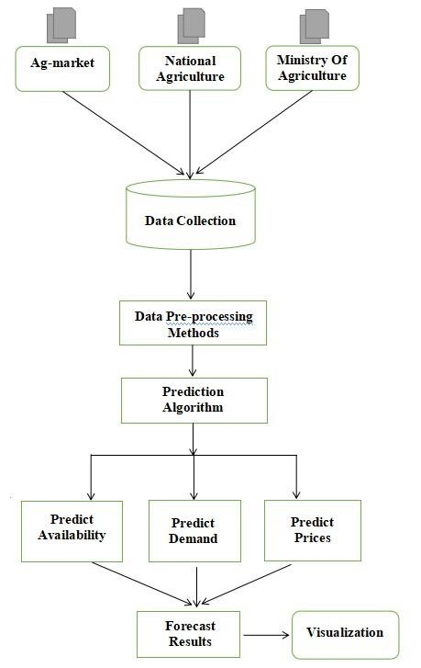

The process of transporting data from one or more sources to a target site for further processing and analysis. Agricultural data of previous years are collected and used by the system. This dataset includes crop areas, types of crops cultivated, nature of the soil, yields and overall crops consumption. Data is gathered from authentic websites like Ministry of Agriculture & Farmers Welfare, Food and Agriculture Organization, APEDA, NITI Aayog, Agriculture Marketing Department of Karnataka, Indiastat.com and Competition Commission. Additionally, some unpublished data has also been procured from APMCs and district agriculture and horticulture departments. The weather condition data is collected from authentic sources like IMD.

Crop prices are affected by several factors such as climate, supply and demand. The obtained data contained huge number of outliers, null values and many discontinuous values. An outlier is a data point that is noticeably different from the rest. They represent errors in measurement, bad data collection, or simply show variables not considered when collecting the data. Learning algorithms are sensitive to outliers. Using Python libraries in Excel we managed to reduce the outliers and error values. Since demand data was unaccounted in any authentic websites, simulated data has been used for analysis. We calculated this data by making use of demand curve formula which fits the curve. Yearly data are collected for forecasting because it has less noise. As the data for demand was simulated, the required accuracy is partially met, when actual data is available, accuracy of the model can be increased.

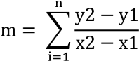 y = Max Price (Rs. /Quintal) x = Production (Kg)

The equation that depicts the relationship between the price of a certain commodity and the quantity of that commodity that is demanded at that price can be given as



Linear demand curve

a = Production (Kg) m= Slope

P = Price (Rs)

The algorithms and tools thus selected are familiarized by carrying out some test runs and finding the most optimal algorithm to satisfy the needs. Algorithms like Linear regression, Logistic regression and Random Forest are used for prediction and classification. Linear regression is initially carried out to predict the value of a variable based on the value of another independent variable. The chosen algorithms are then implemented in sequence to design a predictive model.

Model validation is carried out in two phases. In the initial phase, real time data is given as an input to the designed predictive model to obtain the forecasting information. These results are compared, verified and validated against the authentic data to check for accuracy. In the second phase, Orange3, a Python-based data visualization, machine learning and data mining tool kit has been used for explorative rapid qualitative data analysis to validate our prediction model.

# [CHAPTE](https://1.bp.blogspot.com/-dODuK8N5h1Q/Wlnyb3V9HFI/AAAAAAAACL4/WxQtCJ1pM5wccDABg4wIrTBUB0vlikXQQCLcBGAs/s1600/poly1.jpg)R 7 IMPLEMENTATION

1. **IMPLEMENTATION**

Implementation is the stage where the theoretical design is turned into a working system. The most crucial stage in achieving a new successful system and in giving confidence on the new system for the users that it will work efficiently and effectively.

The system can be implemented only after thorough testing is done and if it is found to work according to the specification. It involves careful planning, investigation of the current system and it constraints on implementation, design of methods to achieve the change over and an evaluation of change over methods a part from planning.

Two major tasks of preparing the implementation are education and training of the users and testing of the system. The more complex the system being implemented, the more involved will be the system analysis and design effort required just for implementation.

The implementation phase comprises of several activities. The required hardware and software acquisition is carried out. The system may require some software to be developed. For this, programs are written and tested. The user then changes over to his new fully tested system and the old system is discontinued.

## TESTING

The testing phase is an important part of software development. It is the Information zed system will help in automate process of finding errors and missing operations and also a complete verification to determine whether the objectives are met and the user requirements are satisfied. Software testing is carried out in three steps:

1. The first includes unit testing, where in each module is tested to provide its correctness, validity and also determine any missing operations and to verify whether the objectives have been met. Errors are noted down and corrected immediately.
2. Unit testing is the important and major part of the project. So errors are rectified easily in particular module and program clarity is increased. In this project entire system is divided into several modules and is developed individually. So unit testing is conducted to individual modules.
3. The second step includes Integration testing. It need not be the case, the software whose modules when run individually and showing perfect results, will also show perfect results when run as a whole.

# [CHAPTE](https://1.bp.blogspot.com/-dODuK8N5h1Q/Wlnyb3V9HFI/AAAAAAAACL4/WxQtCJ1pM5wccDABg4wIrTBUB0vlikXQQCLcBGAs/s1600/poly1.jpg)R 8 SNAPSHOTS

* 1. **SNAPSHOTS**

**OUTPUT** **1:**

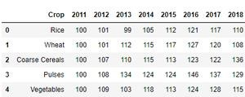

**OUTPUT 2:**

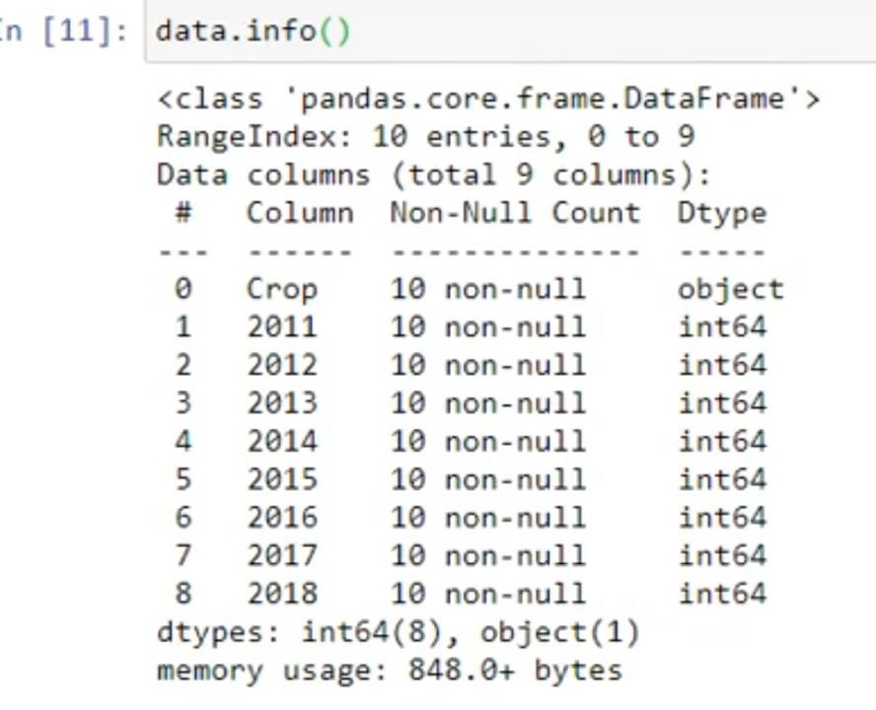

**O**

**UTPUT 3**

**:**

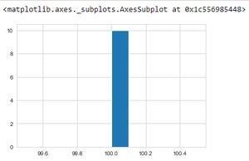

**The above program depicts the crop production data in the year 2011 using histogram.**

**OUTPUT 4:**

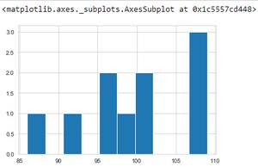

**The above program depicts the crop production data in the year 2012 using histogram.**

**OUTPUT 5:**

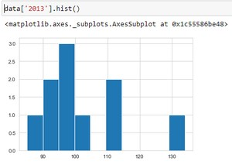

**The above program depicts the crop production data in the year 2013 using histogram.**

**OUTPUT 6:**

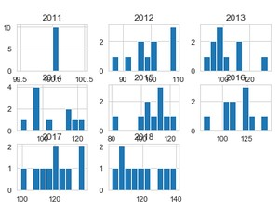

**The above program depicts the crop production data of all the available time periods(year) using multiple histograms.**

**OUTPUT 7:**

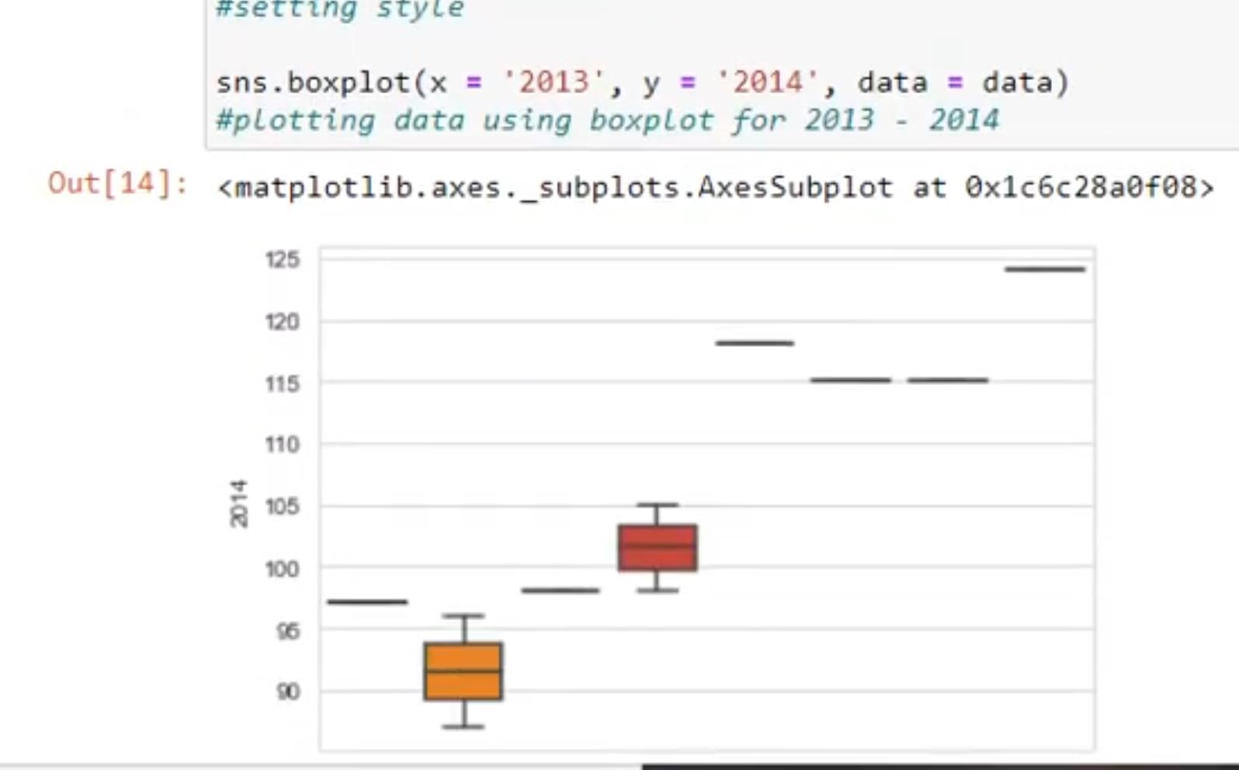

**Comparing crop productions in the year 2013 and 2014 using box plot.**

**OUTPUT 8:**

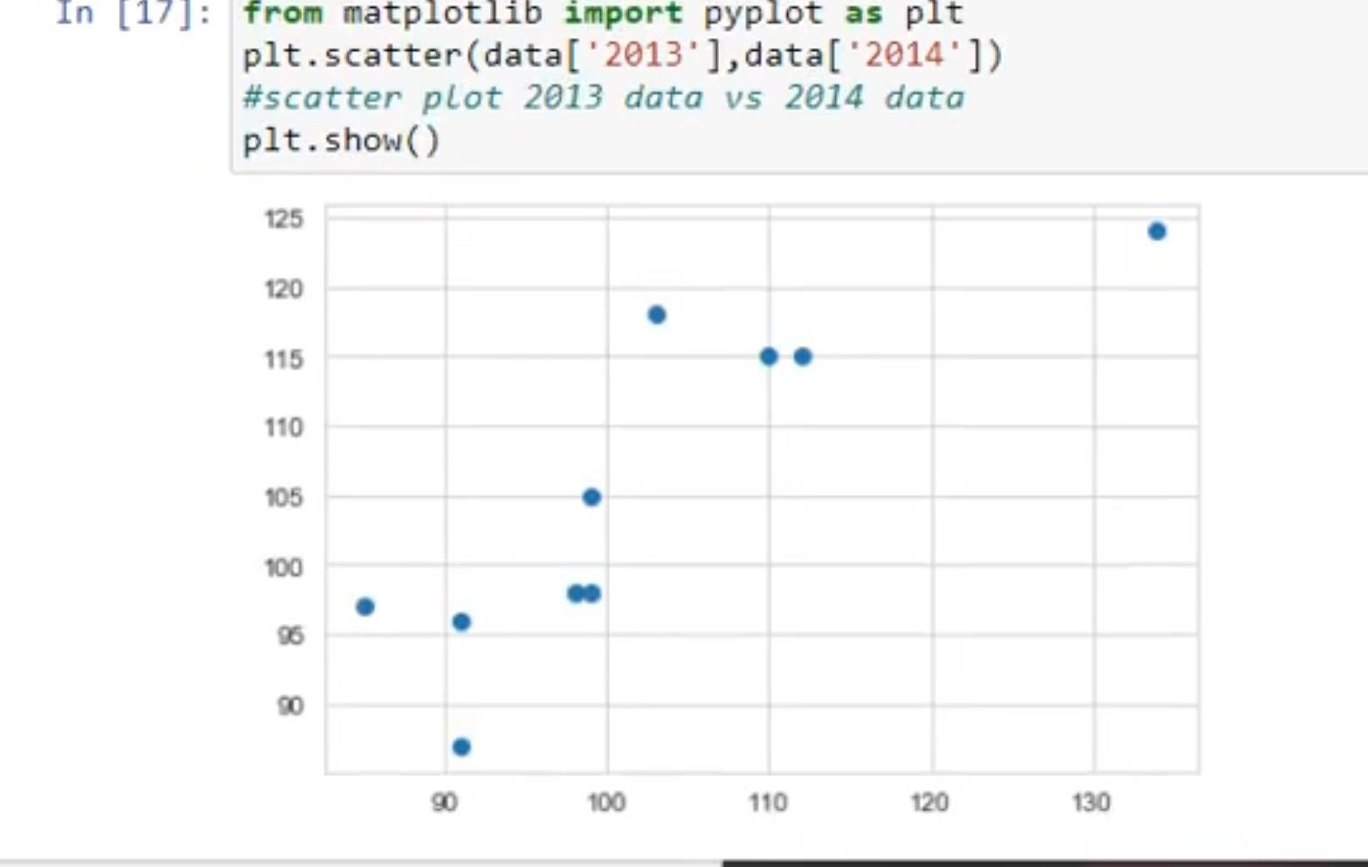

**Comparing crop production in the year 2013 and 2014 using scatter plot.**

**OUTPUT 9:**

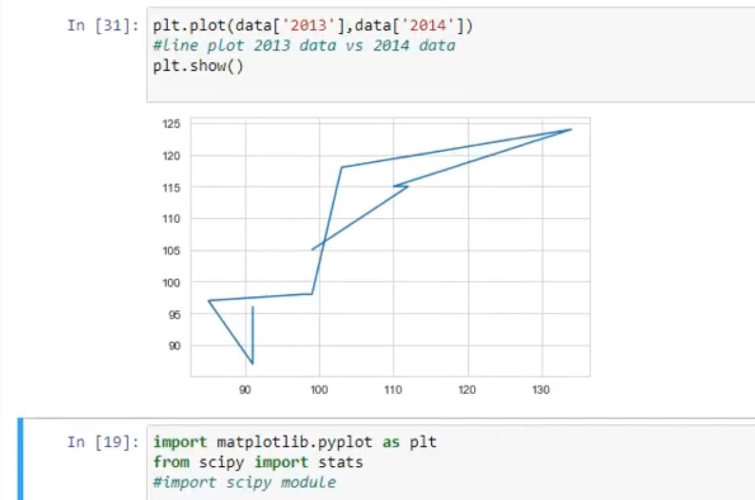

**Comparing crop productions in the year 2013 and 2014 using box plot.**

**OUTPUT 10:**

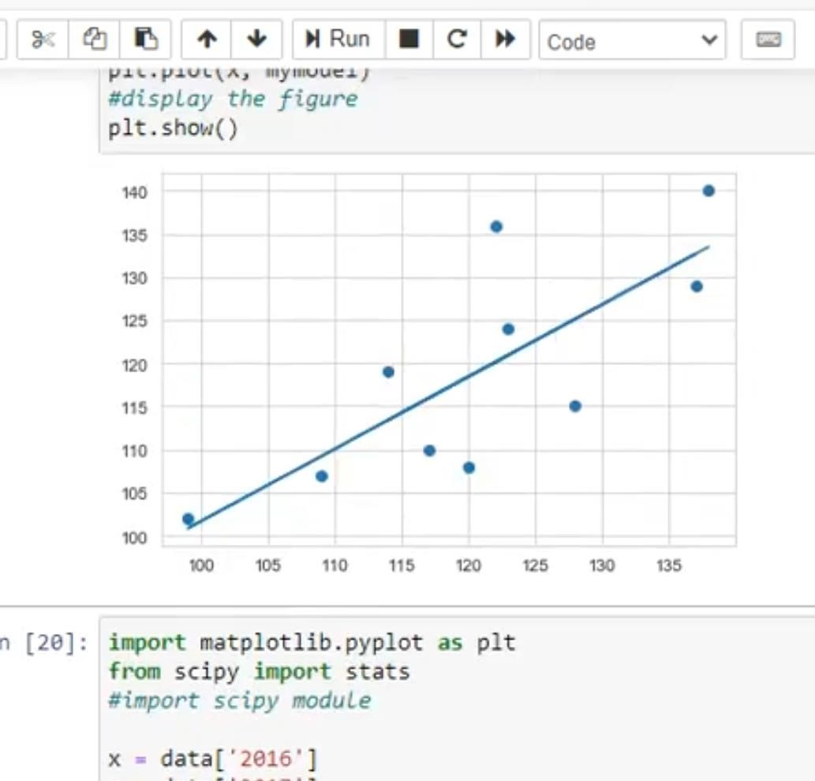

**Applying linear regression to visualize and compare predicted crop production data between the year 2017 and 2018.**

# [CHAPTE](https://1.bp.blogspot.com/-dODuK8N5h1Q/Wlnyb3V9HFI/AAAAAAAACL4/WxQtCJ1pM5wccDABg4wIrTBUB0vlikXQQCLcBGAs/s1600/poly1.jpg)R 9 CONCLUSION

* 1. **CONCLUSION**

The proposed system is about the collection of massive dataset collection, the problems in collecting the dataset and also includes collecting the dataset both in the internet as well as in the traditional way. The massive development in computer technology brings need of most of the data so they produced the system of collecting a greater number of datasets. By considering this dataset, a Supply-Demand Prediction forecasting model has been developed in this work that guides the farmers in selecting the appropriate crops to grow. This in turn suffices the actual demand of the society, minimizing the loss for both farmers as well as consumers at peak times.

This model helps in achieving equilibrium in demand and supply of TOP crops that could effectively solve the current crisis. The package was designed in such a way that future modifications can be done easily.

The following conclusions can be deduced from the development of the project:

* Automation of the entire system improves the efficiency
* It provides a friendly graphical user interface which proves to be better when compared to the existing system.
* It gives appropriate access to the authorized users depending on their permissions.
* It effectively overcomes the delay in communications.
* Updating of information becomes so easier
* System security, data security and reliability are the striking features.
* The System has adequate scope for modification in future if it is necessary.

# REFERENCE

1. Department of Agriculture welfare https://agricoop.nic.in/en/all-india-cropsituation
2. Top ten India Crops https://www.mapsofindia.com/top-ten/india-crops/
3. Indian Crops https://www.fao.org/india/fao-in-india/india-at-a-glance/en/
4. Production Of Important Crops in Three Largest Producing State https://www.indiabudget.gov.in/economicsurvey/doc/stat/
5. Production Of Important Crops in Three Largest Producing States https://www.safalta.com/blog/major-crops-and-their-states-in-india
6. Major Cropping Seasons https://byjus.com/free-ias-prep/major-croppingseasons-in-india/
7. Major Crops in India https://unacademy.com/content/upsc/studymaterial/indian-geography/major-crops-in-india/
8. Top 10 Agriculture States https://www.tractorjunction.com/blog/top-10agriculture-states-in-india/
9. Agricultural market (2021) http://agmarknet.gov.in/PriceTrends/Default.aspx. Accessed 12 Decc2021
10. Ahamed, N.T. Mahmood, N. Hossain, M.T. Kabir, K. Das, F. Rahman, R.M. Rahman Applying data mining techniques to predict annual yield of major crops and recommend planting different crops in different districts in Bangladesh 2015 IEEE/ACIS 16th International Conference on Software Engineering, Artificial Intelligence, Networking and Parallel/Distributed Computing, SNPD 2015 - Proceedings (2015)
11. S.H. Bhojani, N. Bhatt Wheat crop yield prediction using new activation functions in neural network
12. H. Cheng, L. Damerow, Y. Sun, M. Blanke Early yield prediction using image analysis.